PROGRAM 7 (CO3)

AIM : Implement Intent to navigate between multiple activities

XML

MainActivity

*<?*xml version="1.0" encoding="utf-8"*?>*<androidx.constraintlayout.widget.ConstraintLayout xmlns:android="http://schemas.android.com/apk/res/android"  
 xmlns:app="http://schemas.android.com/apk/res-auto"  
 xmlns:tools="http://schemas.android.com/tools"  
 android:layout_width="match_parent"  
 android:layout_height="match_parent"  
 tools:context=".MainActivity">  
  
 <Button  
 android:id="@+id/button2"  
 android:layout_width="160dp"  
 android:layout_height="59dp"  
 android:text="Go"  
 android:textAppearance="@style/TextAppearance.AppCompat.Display1"  
 app:layout_constraintBottom_toBottomOf="parent"  
 app:layout_constraintEnd_toEndOf="parent"  
 app:layout_constraintStart_toStartOf="parent"  
 app:layout_constraintTop_toTopOf="parent" />  
  
 <LinearLayout  
 android:id="@+id/linearLayout"  
 android:layout_width="match_parent"  
 android:layout_height="match_parent"  
 android:orientation="vertical"  
 tools:layout_editor_absoluteX="28dp"  
 tools:layout_editor_absoluteY="184dp">  
  
 <TextView  
 android:id="@+id/textView3"  
 android:layout_width="match_parent"  
 android:layout_height="336dp"  
 android:gravity="center"  
 android:text="First Page"  
 android:textAlignment="center"  
 android:textAppearance="@style/TextAppearance.AppCompat.Display1" />  
 </LinearLayout>  
</androidx.constraintlayout.widget.ConstraintLayout>

XML

Home

*<?*xml version="1.0" encoding="utf-8"*?>*<androidx.constraintlayout.widget.ConstraintLayout xmlns:android="http://schemas.android.com/apk/res/android"  
 xmlns:app="http://schemas.android.com/apk/res-auto"  
 xmlns:tools="http://schemas.android.com/tools"  
 android:layout_width="match_parent"  
 android:layout_height="match_parent"  
 tools:context=".Home">  
  
 <Button  
 android:id="@+id/button"  
 android:layout_width="170dp"  
 android:layout_height="62dp"  
 android:text="Go Back"  
 android:textAppearance="@style/TextAppearance.AppCompat.Display1"  
 app:layout_constraintBottom_toBottomOf="@+id/linearLayout2"  
 app:layout_constraintEnd_toEndOf="parent"  
 app:layout_constraintStart_toStartOf="parent"  
 app:layout_constraintTop_toTopOf="parent" />  
  
 <LinearLayout  
 android:id="@+id/linearLayout2"  
 android:layout_width="match_parent"  
 android:layout_height="match_parent"  
 android:orientation="vertical">  
  
 <TextView  
 android:id="@+id/textView"  
 android:layout_width="match_parent"  
 android:layout_height="341dp"  
 android:gravity="center"  
 android:text="Second Page"  
 android:textAlignment="center"  
 android:textAppearance="@style/TextAppearance.AppCompat.Display1" />  
 </LinearLayout>  
</androidx.constraintlayout.widget.ConstraintLayout>

JAVA

MainActivity

package com.example.loginintent;  
  
import androidx.appcompat.app.AppCompatActivity;  
  
import android.content.Intent;  
import android.os.Bundle;  
import android.view.View;  
import android.widget.Button;  
  
  
public class MainActivity extends AppCompatActivity {  
 Button b1;  
  
 @Override  
 protected void onCreate(Bundle savedInstanceState) {  
 super.onCreate(savedInstanceState);  
 setContentView(R.layout.*activity_main*);  
  
 b1 =findViewById(R.id.*button2*);  
  
 *//implement Onclick event for Explicit Intent* b1.setOnClickListener(new View.OnClickListener() {  
 @Override  
 public void onClick(View v) {  
  
 Intent intent = new Intent(getApplicationContext(), Home.class);  
 startActivity(intent);  
  
  
 }  
 });  
 }  
}

Home

package com.example.loginintent;  
  
import androidx.appcompat.app.AppCompatActivity;  
  
import android.content.Intent;  
import android.os.Bundle;  
import android.view.View;  
import android.widget.Button;  
  
public class Home extends AppCompatActivity {  
  
 Button b1;  
  
 @Override  
 protected void onCreate(Bundle savedInstanceState) {  
 super.onCreate(savedInstanceState);  
 setContentView(R.layout.*activity_home*);  
  
 b1 = findViewById(R.id.*button*);  
  
 *//implement Onclick event for Explicit Intent* b1.setOnClickListener(new View.OnClickListener() {  
 @Override  
 public void onClick(View v) {  
  
 Intent intent = new Intent(getApplicationContext(), MainActivity.class);  
 startActivity(intent);  
  
  
 }  
 });  
  
 }  
  
}

OUTPUT

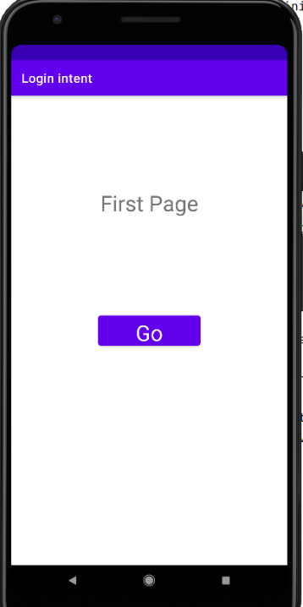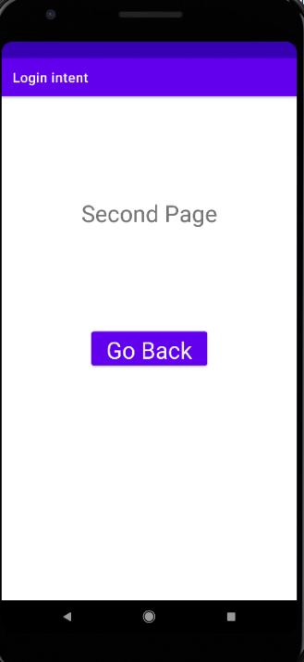

RESULT : Program to implement Intent to navigate between multiple activities successfully executed and output verified